CORPORTATE EMPLOYEE ATTRITION ANALYTICS

PROJECT REPORT

Submitted by
Ms.S.TAMIZH | Reg.No.422719104035
Ms.K.BABYSHALINI | Reg.No.422719104007
Ms.G.RUBIYA | Reg.No.422719104026
Ms.A.ARTHI | Reg.No.422719104005

in partial fulfilment for the award of the degree
of

BACHELOR OF ENGINEERING
in
COMPUTER SCIENCE AND ENGINEERING

V.R.S. COLLEGE OF ENGINEERING AND TECHNOLOGY ARASUR – 607107, VILUPPURAM DISTRICT
ANNA UNIVERSITY: CHENNAI 600 025
NOVEMBER 2022

ANNA UNIVERSITY: CHENNAI 600 025

BONAFIDE CERTIFICATE
Certified that this project report “Corportate Employee Attrition Analytics”is The Bonafide work of“Ms.S.TAMIZH[Reg.No.422719104035],Ms.K.BABYSHALINI[Reg.No.422719104007] and Ms.G.RUBIYA [Reg.No.422719104026] Ms.A.ARTHI [Reg.No.422719104005] ”who carried out the project work under our supervision.

SIGNATURE | SIGNATURE
Mr. K. RAMESH, M.E., | Mr.N.GOBINATHAM, M.E.,
HEAD OF THE DEPARTMENT | SUPERVISOR
Department of Computer Science | Department of Computer Science
and Engineering, | and Engineering,
V.R.S. College of Engineering and | V.R.S. College of Engineering and
Technology, Arasur-607107, | Technology, Arasur-607107,
Villupuram. | Villupuram.
Project viva-voce examination held on ……………….

INTERNAL EXAMINER EXTERNAL EXAMINER
TABLE OF CONTENT

CHAPTER NO | TITLE | PAGE NO
1 | INTRODUCTION | 4
 | 1.1 Project Overview | 4
 | 1.2 Purpose | 4
2 | LITERATURE SURVEY | 4
 | 2.1 Existing problem | 7
 | 2.2 References | 7
 | 2.3 Problem Statement Definition | 8
3 | IDEATION & PROPOSED SOLUTION | 9
 | 3.1 Empathy Map Canvas | 9
 | 3.2 Ideation & Brainstorming | 10
 | 3.3 Proposed Solution | 12
 | 3.4 Problem Solution fit | 13
4 | REQUIREMENT ANALYSIS | 14
 | 4.1 Functional requirement | 14
 | 4.2 Non-Functional requirements | 14
5 | PROJECT DESIGN | 15
 | 5.1 Data Flow Diagrams | 15
 | 5.2 Solution & Technical Architecture | 15
 | 5.3 User Stories | 16
6 | PROJECT PLANNING & SCHEDULING | 17
 | 6.1 Sprint Planning & Estimation | 18
 | 6.2 Sprint Delivery Schedule | 18
 | 6.3 Reports from JIRA | 20
7 | VIRTUALIZATION OF DATA SET | 21
8 | RESULTS | 23
 | 8.1 Performance Metrics | 23
9 | ADVANTAGES & DISADVANTAGES | 24
10 | CONCLUSION | 26
 | 10.1 GitHub& Project Demo Link | 26

1. INTRODUCTION

1.1 Project Overview

- The objective of this project is to predict the attrition rate for each employee, to find who’s more likely to leave the organisation.
- It will help organization to find ways to prevent attrition or plan in advance the hiring of the new candidate.
- Attrition proves to be a costly and time-consuming problem for the organization and it also leads to the loss of probability.
- The scope of the project extends to companies to all industries

1.2 Purpose

- Employee purpose is the sense of meaning employees have behind their work and how their values align with a business.
- It’s all about enabling and encouraging employees to bring purpose to their professional environment and working life.
- A purpose-driven workplace is one where employees have the opportunity to work on what is meaningful for them.
- When it comes to company purpose, it’s about a company’s reason for being; it’s what their founding members saw wrong in the world and wanted to fix.
- Employee Purpose is what employees see wrong in the world and want to improvethe two are different, but linked by a joint vision for something better.

2. LITERATURE SURVEY
2.1 Existing problem
Title:-A STUDY ON EMPLOYEE ATTRITION WITH REFERENCE TO LANSONTOYOTA, CHENNAI., V Krishna Priya Value Institute of Science Technology and AdvancedStudies., Article in Man in India · January 2017. The present study is bound to assess the causes of attrition and to findtheexpectation of employees to retain them in the organization. The primarydetails collected through the structured questionnaire from100stakeholdersthrough stratified random sampling. It includes various levels of employeesinthe automobile industry. Chi-square, Anova, comparition and correlationareused for the analysis. The result shows that employees with experience arenotpromoted due to which they are dissatisfied. Employees receiving lowincomeno promotion or no career growth ,developing stress may look for betteropportunities. Employees except job security to retain themselves intheorganization. Due to lack of growth opportunities they prefer to change job. So,the organization has to provide atleast required benefits and rewards toemployees to make them retain and explore their career.

Title:- HR analytics: Employee attrition analysis using logistic regression., To cite this article: I Setiawan et al 2020 IOP Conf. Ser.: Mater. Sci. Eng. 830032001 Employee attrition can become a serious issue because of the impacts ontheorganization’s competitive advantage. It can become costly for an organization. The cost ofemployee attrition would be the cost related to the humanresourceslife cycle, lost knowledge,employee morale, and organizational culture. Thisstudy aimed to analyzed employee attritionusing logistic regression. The result tobe obtained can be used by the management to understand what modificationsthey should perform to the workplace to get most of their workers tostay. Thedata for the study were around four thousand employees, covering261days (one year workingdays) during 2015 — the data period betweenJanuaryand December. We use R for data my integration, exploratory data analysis, datapreparation, logistic regression, model evaluation,and visualization. Thestudyhas five steps: (1) data collection and business understanding, (2)datapre-processing, (3) exploratory data analysis, (4) model selection and training, and(5) test and evaluation of the model. The result of the study foundelevenvariables as key driving factors for employee attrition. It also showed thatthe model has 75 percent accuracy with 73 percent sensitivity and 75percentspecificity.

Title:- A STUDY ON EMPLOYEE ATTRITION WITH REFERENCE TOLANSONTOYOTA, CHENNAI .,V. Krishna Priya* and H. Hari Harasudha** The present study is bound to assess the causes of attrition and to findtheexpectation of employees to retain them in the organization. The primarydetails collected through the structured questionnaire from100stakeholders,through stratified random sampling. It includes various levels of employeesinthe automobile industry. Chi-square, Anova,comparision and correlationareused for the analysis. The result shows that employees with experience arenotpromoted due to which they are dissatisfied. Employees receiving lowincome,no promotion or no career growth ,developing stress may look for betteropportunities. Employees except job security to retain themselves intheorganization. Due to lack of growth opportunities they prefer to change job. So,the organization has to provide atleast required benefits and rewards toemployees to make them retain and explore their career

Title:- A STUDY ON EMPLOYEE ATTRITION WITH REFERENCE TOLANSONTOYOTA, CHENNAI.,V. Krishna Priya* and H. Hari Harasudha** The present study is bound to assess the causes of attrition and to find the expectationof employees to retain them in the organization. The primary data is collectedthroughthe structured questionnaire from 100 stakeholders, through stratifiedrandomsampling. It includes various levels of employees in the automobile industry. Chi-square, Anova, comparision and correlation are used for the analysis. The result shows thatemployees with experience are not promoted due to which they are dissatisfied. Employees receiving low income, no promotion or no career growth ,developingstressmay look for better opportunities. Employees except job security to retain themselves inthe organization. Due to lack of growth opportunities they prefer to change job. So, theorganization has to provide atleast required benefits and rewards to employees tomakethem retain and explore their career.

Title:-Predicting Employee Attrition Using Machine Learning Approaches., Academic Editor: Federico Divina .Appl. Sci. 2022, 12(13), 6424; https://doi.org/10.3390/app12136424 Employee attrition refers to the natural reduction in the employees in an organization due tomanyunavoidable factors.
Employee attrition results in a massive loss for an organization. The Societyfor Human Resource Management (SHRM) determines that USD 4129 is the average cost-per-hire for anew employee. According to recent stats, 57.3% is the attrition rate in the year 2021. Aresearchstudyneeds to be implemented to find the causes of employee attrition and a learning framework to predict employee attrition. This research study aimed to analyzingtheorganizational factors that causedemployee attrition and the prediction of employee attrition using machine learning techniques. Thefour machine learning techniques were applied in comparison. The proposed optimized Extra TreesClassifier (ETC) approach achieved an accuracy score of 93% for employee attrition prediction. Theproposed approach outperformed recent state-of-the-art studies. The Employee ExploratoryDataAnalysis (EEDA) was applied to determine the factors that caused employee attrition. Our studyrevealed that the monthly income, hourly rate, job level, and age are the key factors that causeemployee attrition. Our proposed approach and research findings help organizations overcomeemployee attrition by improving the factors that cause attrition.

Title:- ANALYZING EMPLOYEE ATTRITION USING DECISION TREE ALGORITHMS., Also D. & Adeyemo A. B. Department of Computer Science University of IbadanIbadan, Nigeria Employee turnover is a serious concern in knowledge based organizations. When employees leavean organization, they carry with them invaluable tacit knowledge which is often the source of competitive advantage for the business. In order for an organization to continually have a higher competitive advantage over its competition, it should make it a duty to minimize employee attrition. This study identifies employee related attributes that contribute to the prediction of employees’ attrition in organizations. Three hundred and nine (309) complete records of employees of one of the Higher Institutions in Nigeria who worked in and left the institution between 1978 and 2006wereused for the study. The demographic and job related records of the employee were the main data which were used to classify the employee into some predefined attrition classes. Waikato Environment for Knowledge Analysis (WEKA) and See5 for Windows were used to generate decision tree models and rule-sets. The results of the decision tree models and rule-sets generated were then used for developing a a predictive model that was used to predict new cases of employee attrition. A framework for a software tool that can implement the rules generated in this study was also proposed.

Title:- Early Prediction of Employee Attrition in Software Companies-Application of Data Mining Techniques 1 ., Vishnuprasad Nagadevara, Vasanthi Srinivasan, Indian Instituteof Management Bangalore, India Employee retention is one of the biggest challenges in IT companies all over the world. Different companies adopt different strategies to retain the employees. These strategies includelarge increases in compensation, liberal perks, frequent job rotations, as well as travel and stay abroad. However, literature on turnover indicates that a person’s intention to quit is a function of demographic characteristics, job characteristics and organizational characteristics. Individual who have an intention to quit are also likely to engage in other withdrawal behaviour likeabsenteeism and late-coming. This paper uses data on demographics and the withdrawal behaviour like absenteeism and late-coming to predict turnover. It applies various data miningtechniques to identify turnover in organizations. This exploratory study identifies four variableswhich could enhance the accuracy of prediction of turnover Further research on the variablesneeds to be done to contribute to prediction and also identify the possible reasons for attrition•

Title:- Market-aware Heterogeneous Graph Neural Network for Employee TurnoverPrediction., WSDM '22: Proceedings of the Fifteenth ACM International Conference onWebSearch and Data MiningFebruary 2022 Pages 353–362 As an emerging initiative of proactive human resource management, employee turnover prediction critically important for employers to retain talents and avoid the loss of intellectual capital. Whileconsiderable research efforts have been made in this direction, most of them only focus on modelling thewithin-company career trajectories of employees where the influence of external job market hasbeen largely neglected. To this end, in this paper, we propose an enhanced framework of employeeturnover prediction by jointly model the turnover clues from both internal and external views. Specifically, from the external-market view, we construct a heterogeneous graph which connects theemployees with external job markets through shared skills. In this way, we can capture the potential popularity of employees in external markets specific to skills. Meanwhile, from the internal-companyview, we design a graph convolutional network with hierarchical attention mechanismto capturetheinfluence of organizational structure (e.g., superiors, subordinates, and peers) and colleagues withsimilar skills. Furthermore, both modules are model with Bidirectional LSTMand survival analysisto learn effective and dynamic representations of employee turnover prediction. Finally, we conduct extensive experiments on a large-scale real-world talent dataset with state-of-the-art methods, whichclearly demonstrate the effectiveness of our approach as well as some interesting findings that couldhelp us understand the employee turnover patterns, such as different impacts of external systems andcollaborators from different groups.

2.2 References
Abdulquadri Ade, Ajagbe Musibau Akintunde, Sholanke Anthony Babatunde, Sani Tolani Abdulrahman, (2015), “Impact of Employee Turnover in Small and Medium Construction Firms: A Literature Review”, International Journal of Engineering Research & Technology (IJERT), Volume 4, Issue 2, (p. 976)

Chandrasekar, K. (2011). Managing Attrition: The Real Problem Behind the Growth of Business Process Outsourcing (BPO) Companies. Journal of Social Welfare & ManagementN 3.

David Shine, (2015), “Attrition in IT”, International Journal Of Core Engineering & Management (IJCEM), Volume 2, Issue 1, (p. 236)

DoranceJeen S. Batty, (2014), “A Study on Attrition – Turnover Intentions in retail Industry”, International Journal of Business and Administration Research Review”, Volume 1, Issue 3, (p. 55)
Farooque Asma, Habibuddin, (2015), “Employee Attrition Analysis of Hotel Industry”, International Journal of Advancement in Engineering Technology, Management & Applied Science, Volume 2, Issue 12, (p. 34)

2.3 Problem Statement Definition



3. IDEATION & PROPOSED SOLUTION

3.1 Empathy Map Canvas

3.2 Ideation & Brainstorming

Step-1: Team Gathering, Collaboration and Select the Problem Statement

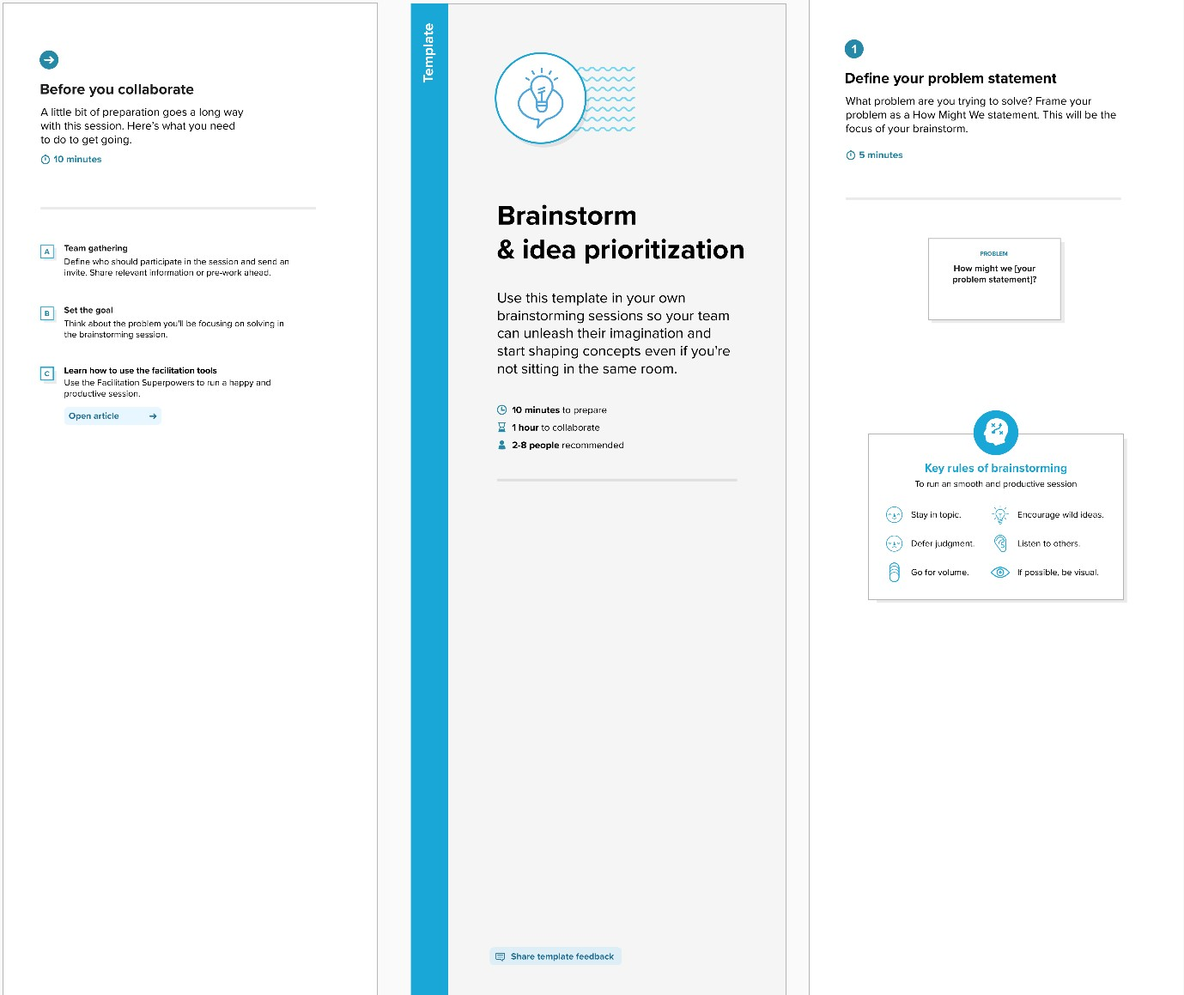

Step-2: Brainstorm, Idea Listing and Grouping

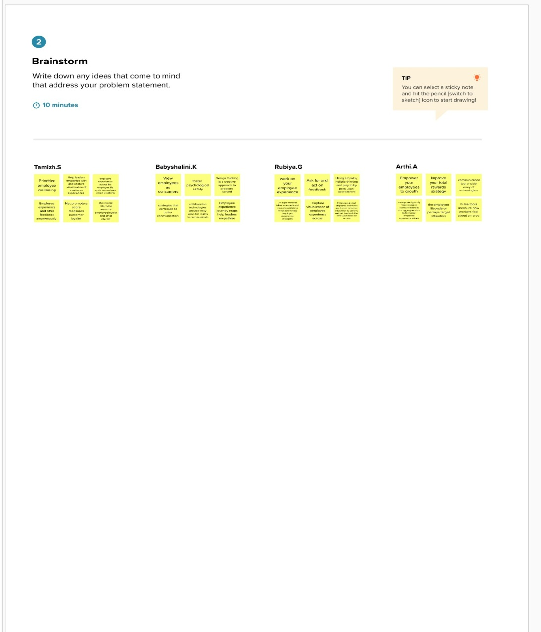

Step-3: Idea Prioritization

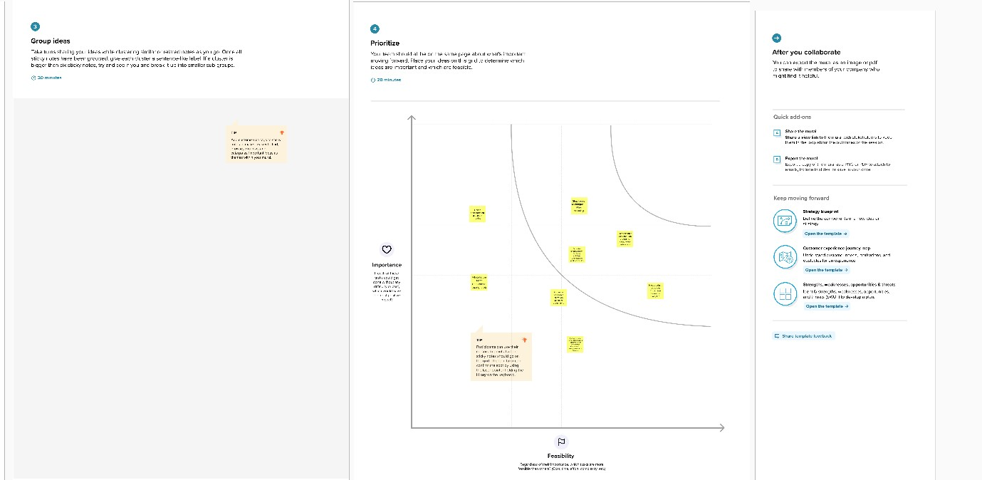

3.3 Proposed Solution

Parameter | Description
Problem Statement  (Problem to be solved) | There are times when employees stay with the organization for long which might mean that they are getting to proof their pay scale
Idea / Solution  description | Many a time when some people leave an organization they open gates new ideasMostly employees who are in the organization get used to the working atmosphere and get complacent This means lack of risk and definitely none wides.
Novelty / Uniqueness | Turnover on futures contracts is calculated by adding the profit and loss (called net profit). For options, premium received on sale is also added to the net profit, which has now been removed
Social Impact /  Customer Satisfaction | The direct impacts are relatively easy to measure: costs must be incurred to recruit and train new employees. During the recruitment process, other employees generally see an increase in their workload which can result overtime costs, but also affect their own productivity.
Business Model  (Financial Benefit) | employees and having them replaced by others can lead to a culture clash such Losing within the organization, with impacts on effective collaboration and employee engagement. Extended productivity: Employee productivity increases over a period of time as they become more familiar with their role
Scalability of Solution | a pleasant work environment. The work environment is the space where employees full fill their job responsibilities Appoint the right leadership Give employees creative freedomPrioritize professional growth Offer competitive compensation and Foster benefits.

3.4 Problem Solution fit

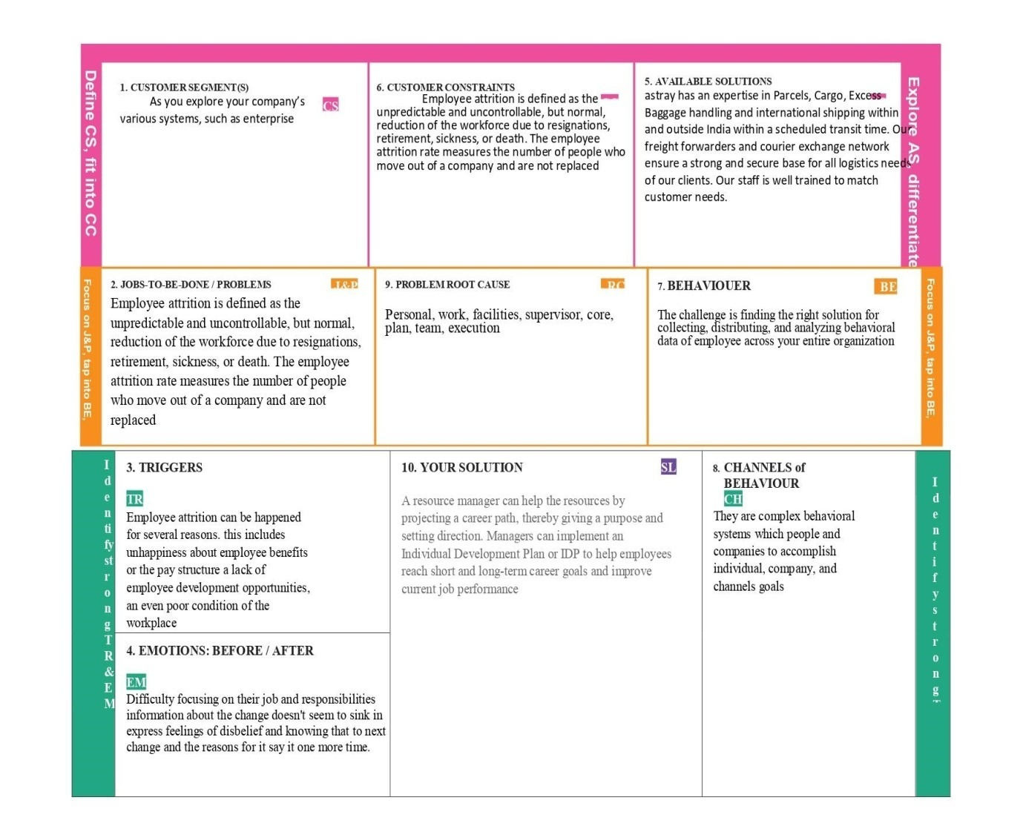

4. REQUIREMENT ANALYSIS

4.1Functionalrequirement

FR No | Functional Requirement (Epic) | SubRequirement (Story / Sub-Task)
FR-1 | Interoperability | Requirement describes whether a software system isinteroperable across different systems.
FR-2 | Security | The functional requirement describes the security aspectof software requirements.
FR-3 | Accuracy: | Accuracy defines a data entered into the system iscorrectly calculated and used by the system and that theoutput is correct.
FR-4 | Compliance | Compliance functional requirements validate that thedeveloped system is compliant to Industrial standards
FR-5 | Organization | Their goal is customer requirement fulfilment.
FR-6 | Tested by the customer mostly | Tested by Software Test engineers and generally nottested by Customers

4.2 Non-Functional requirements

FR No. | Non-Functional Requirement | Description
NFR-1 | Usability | its essence it doesn't specify parts of the system  functionality, only how that functionality is to be  perceived by the user, for instance how easy it mustbe to learn and how efficient it must be for carryingout user tasks
NFR-2 | Security | payroll data is not visible to all the employees in the organization Only the authorized personnel should  have access to the data
NFR-3 | Reliability | website users should be able to access the system99% of the time without any failure
NFR-4 | Performance | funds transfer transaction should not take more than0.5 seconds
NFR-5 | Availability | the system should be available for the users to usethe system anytime of the week they need
NFR-6 | Scalability | the system should be scalable to support unlimitedgrowth of the employees
NFR-7 | Capacity | system should be able to store 1 million recordsof basic customer information
NFR-8 | Efficiency | The interface between the system and user should nottake more than 2 seconds
NFR-9 | Data integrity | the system should not allow phone number to beentered in the data field
NFR-10 | Portability | The system shall be developed for both windows and Mac operating systems platforms

5. PROJECT DESIGN

5.1 Data Flow Diagrams

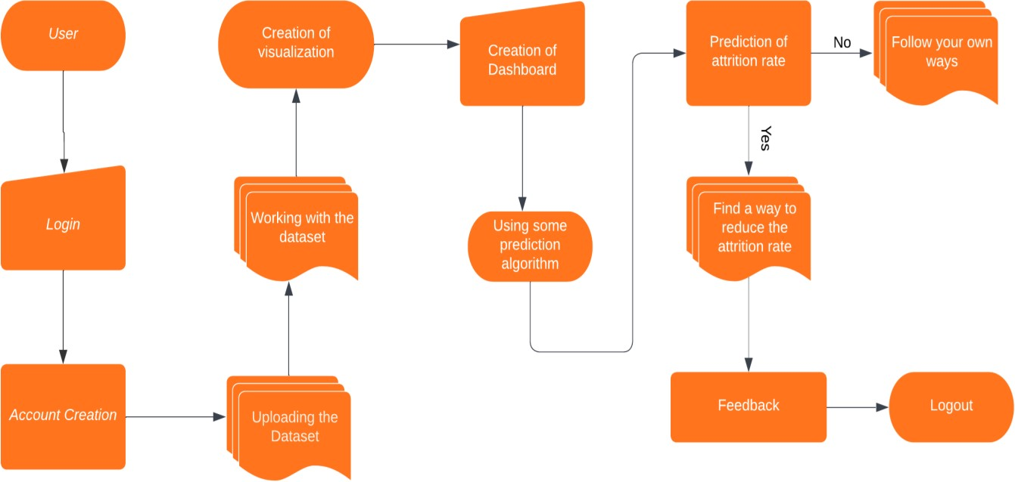

5.2 Solution & Technical Architecture

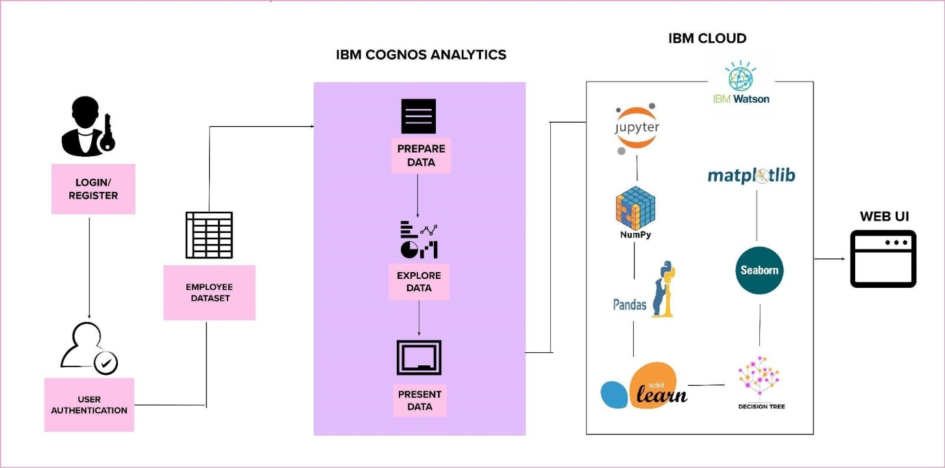

5.3 User Stories

sprint | Functional  Requirement (Epic) | User  Story  Number | User Story / Task | Acceptance criteria | Priority | Release
Customer (Web user) | Registration | User Type | As a user, I can register for the application by entering my email, password, and confirming my password. | I can access my account / dashboard | High | Sprint-1
 |  | USN-2 | As a user, I will receive confirmation email once I have registered for the application | I can receive confirmation email & click confirm | High | Sprint-1
 |  | USN-3 | As a user, I can register for the application through Facebook | I can register & access the dashboard with Facebook Login | Low | Sprint-2
 |  | USN-4 | As a user, I can register for the application through Gmail | I can register & access the dashboard with Gmail Login | Medium | Sprint-1
 | Login | USN-5 | As a user, I can log into the application by entering email & password | I can access my account / dashboard | High | Sprint-1
 | Dashboard | USN-6 | Uploading the Dataset | I can be able to upload my dataset | High | Sprint 2
 |  | USN-7 | Working With Dataset | I can be able to access my dashboard | High | Sprint 2
 |  | USN-8 | Visualization | I can be able to view the visual attrition rate of my dataset | High | Sprint 3
 |  | USN-9 | Working with Dashboard | I can be able to view the various views of the attrition rate | High | Sprint 3
Customer Care Executive |  | USN-10 | Asking Help / Feedback | I can be able to ask help if I can face any issues or  problems while using the webpage | Medium | Sprint 4

6. PROJECT PLANNING & SCHEDULING

6.1 Sprint Planning & Estimation

Sprint | Functional  Requirement (Epic) | User Story Number | User Story / Task | Story Points | Priority | Team  Members
Sprint -1 | Registration | USN-1 | As a user, I can register for the application by entering my email, password, and confirming my password. | 2 | High | Babyshalini.K
Sprint-1 |  | USN-2 | As a user, I will receive confirmation email once I have registered for the application | 1 | High | Tamizh.S
Sprint -2 |  | USN-3 | As a user, I can register for the application through Facebook | 2 | Low | Rubiya. G
Sprint -1 |  | USN-4 | As a user, I can register for the application through Gmail | 2 | Medium | Arthi.A
Sprint -1 | Login | USN-5 | As a user, I can log into the application by entering email & password | 2 | High | Babyshalini.K
Sprint -2 | Dashboard | USN-6 | As a user, I can able to access the dashboard | 4 | Medium | Babyshalini.K
Sprint -2 |  | USN-7 | As a user, I can able to upload my dataset through dashboard | 2 | High | Tamizh.S
Sprint-3 |  | USN-8 | As a user, I can able to done a Data Preprocessing | 3 | Medium | Rubiya. G

6.2 Sprint Delivery Schedule

Sprint | Total Story Points | Duration | Sprint Start Date | Sprint End Date (Planned) | Story Points  Completed (as on  Planned End Date) | Sprint Release Date (Actual)
Sprint-1 | 7 | 3 Days | 28 Oct 2022 | 30 Oct 2022 | 7 | 30 Oct 2022
Sprint-2 | 13 | 4 Days | 31 Oct 2022 | 03 Nov 2022 | 13 | 03 Nov 2022
Sprint-3 | 14 | 5 Days | 07 Nov 2022 | 11 Nov 2022 | 14 | 10 Nov 2022
Sprint-4 | 15 | 5 Days | 12 Nov 2022 | 16 Nov 2022 | 15 | 16 Nov 2022

Sprint-3 | 6 | 14 | 2.33
Sprint-4 | 6 | 15 | 2.5

Sprints | Sprint Duration | Velocity | Actual Velocity
Sprint-1 | 6 | 7 | 1.16
Sprint-2 | 6 | 13 | 2.16
Sprint-3 | 6 | 14 | 2.33
Sprint-4 | 6 | 15 | 2.5

Sprint-1
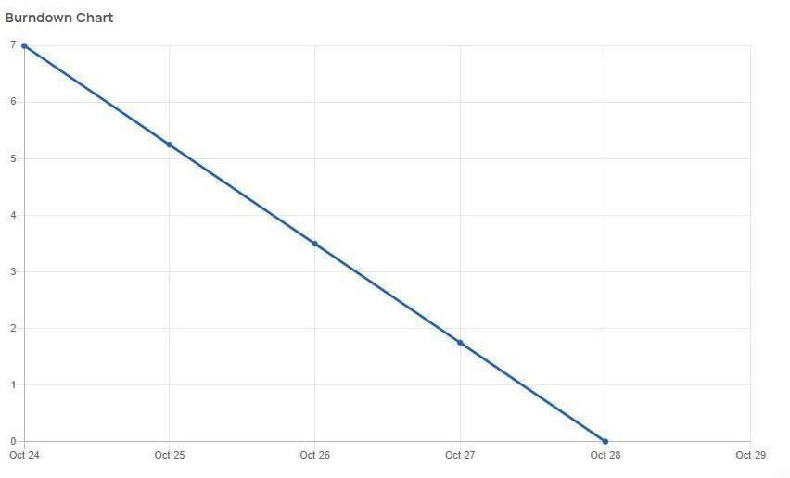

Sprint-2

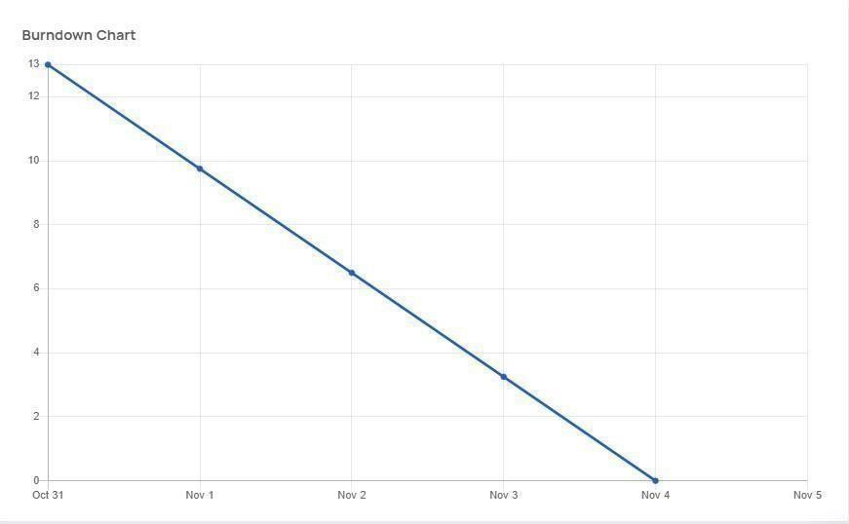

Sprint-3
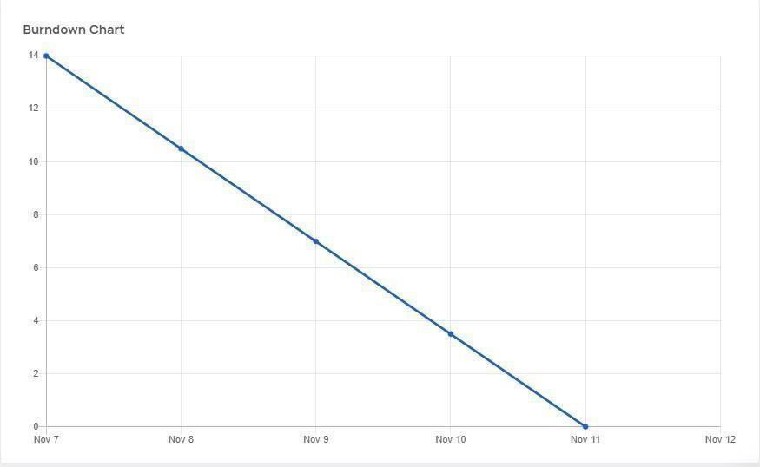

Sprint-4
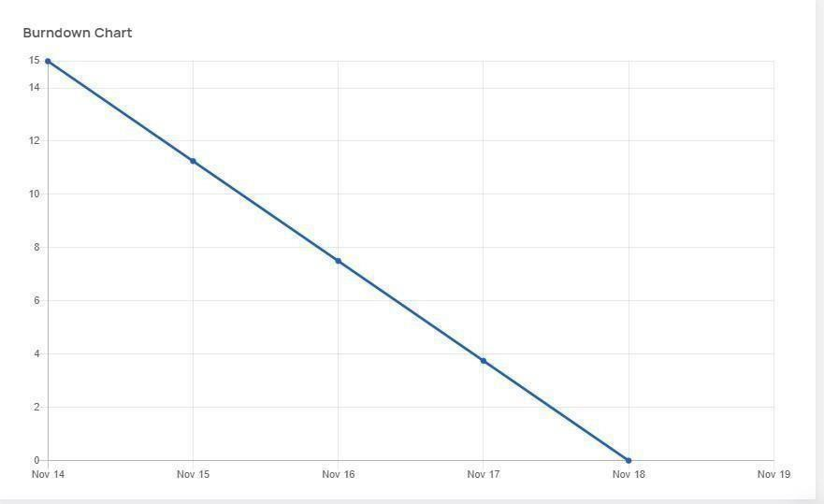

6.3 Reports from JIRA

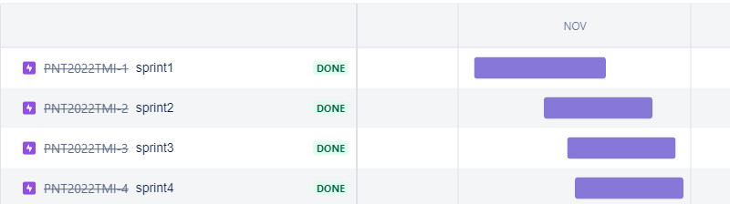

7. VIRTUALIZATION OF DATASET

8. RESULTS

8.1 Performance Metrics

- Quality of Work. Quality trumps quantityespecially when you consider employee productivity.

- Employee Efficiency. An efficient employee is able to maximize their productivity with minimumeffort and expense.
.
- Training Programs.

- Individual Goals

9. ADVANTAGES &DISADVANTAGES

ADVANTAGES

Advantages of Employee Attrition:
Not all turnovers are negative, we generally feel that an employee leaving the organization is detrimental to the organization, but there is a flip side to it.Employees leaving an organization may lead to benefits. This type of job attrition is called ‘healthy attrition’ and is needed for growth and development of an organization

1. Higher manpower costs:
There are times when employees stay with the organization for long, which might mean that they are getting top of their pay scale.This means that these employees are being paid a lot more than others who are doing similar job but are comparatively new in the process This excessive manpower costs leads to financial burden which is generally not identified on a regular run of the companies.

2. Negative effect of people:

There are some employees in an organization who work against the culture of the organization and even affect the working environment.Such employees even go to an extend to impact the loyalty of others and their outlook towards the organization.This could mean they are working against the organization from inside. When such employees leave the organization they lead to more profit than loss.

3. New idea:
Many a time when some people leave an organization they open gates for new talent and new ideas .Mostly employees who are in the organization get used to the working atmosphere and get complacent. This means lack of risk and definitely no new ideas.When they leave there is space for people who have high risk takingcaliber and stop the firm from becoming stagnant.

4. Higher performance:

There are employees who just have been working on a slow pace for years within an organization. They are reasons for poor performance and slow growth.When they leave the organization the team becomes fast paced and the turnover time is decreased considerably. This means reduced cost and satisfied clients.

5. Setting the culture right:

There are times that employees do not care for a lot of organization’s policies which creates a brand for the organization. When strong actions are taken against such employees like asking them to leave because they were affecting the brand name in a negative way would lead to a strong message and create a professional culture in an organization.

DISADVANTAGES

Disadvantages of Employee Attrition:

When employees leave the organization it is a loss to the company, the team and the individuals Employees are the backbone of any organization and their departing may lead to lot of various losses to company on different aspects. The disadvantages can be

1. Decreased overall performance:
The whole business process is affected when an employee leave the organization. It is even more risky when this happen all of a sudden.There is no time to train the new employee who is to take over the job and the whole team gets affected. It can directly be seen in an overall decrease of performance of the team.

2. Daily task management:
Sudden attrition may lead to difficulty in managing daily tasks. Even large organization struggle to manage their task when employees leave jobs, getting small information and managing daily tasks become difficult as they cannot be managed by small current team which is left behind.

3. Increased cost:
This has to be the highest disadvantage to a company when employees leave their jobs. There is increased cost associated with every level of the process – losing and paying the previous employee, hiring a new one, training cost for the new employee.Research shows that these costs are way more than the losses incurred in managing and missing out on work.

4. Lack of knowledgeable employees:
This goes without saying when employees leave an organization they take with them the experience they have gained overtime.Older employees with their years of experience can take over critical matters which can never be trusted with these new employees.Even with employees who have experience are hired they may suffer at taking care of critical business matter as they are new to company’s policies, culture and current employees.

5. Create a Negative image:
It is not just that employees are looking for job, even organizations are on the outlook of qualified professionals. When any company has high attrition rate it negatively impact the brand of the organization.Recruiters’ state that they find it difficult to map qualified candidates to the organization, as candidates opts out fearing the attrition rate. The reasons may vary but a negative image work against the organization.

6. Employee development:
Many organizations have various employee developent pmlans and higher attrition rate means losing out on it.

10. CONCLUSION

On the whole, this project was a useful experience. We have gained new knowledge and skills we achieved several of my learning goals. We got insight into professional practice. We learned the different facets of working. We experienced that self-exploration, as in many organisations, is an important factor for the progress of projects. Related to our study we learned more about employee attrition rate prediction and the various approaches and algorithms to achieve the same. There is still alot to discover and to improve. The methods used at the moment are still not standardized and a consistent method is in development. Furthermore we have experienced that it is of importance
of each strategy and how other one is better than the current algorithm and in which application. We found that the internship is not one sided, but it is a way of sharing knowledge, ideas and opinions and
implementing the same to get results. The internship was also good to find out what our strengths and weaknesses are. This helped me to define what skills and knowledge. We believe that our time spent in learning and surfing regarding various algorithms and the mathematics behind was well worth it and contributed to finding an acceptable solution to build a model and predict the employee’s attrition rate. Two main things that we’ve learned the importance of time-management skills and self-motivation. At last this project has gave us new insights and motivation to pursue a career in machine
learning domain

GitHub & Project Demo Link

https://drive.google.com/file/d/1kUNbSV4d8NLonmGLpREbJ4YqtyIs1XXC/view?usp=share_link

